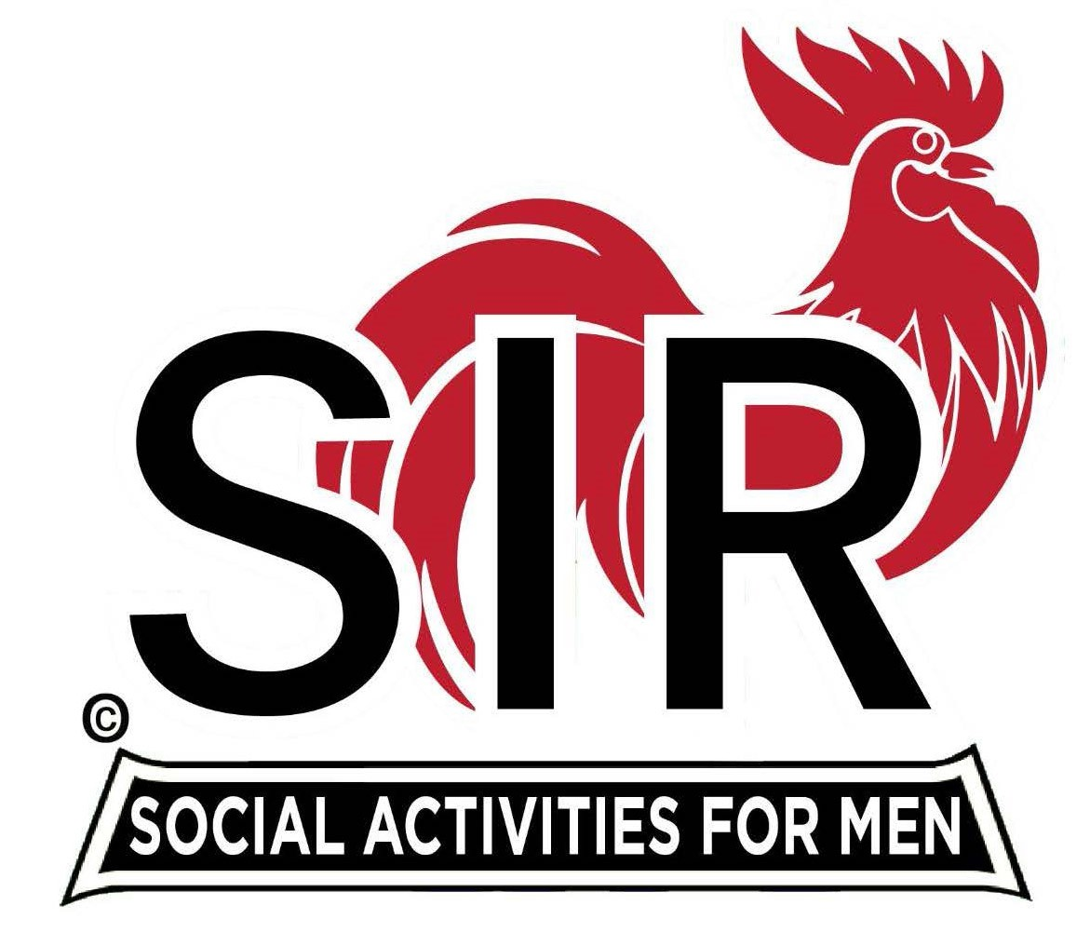
Las Trampas Branch 116
Luncheon Meeting Agenda
January 15, 2024, 10:30 AM
DRAFT

10:30 Check – In
Greeters at the door – Paul Ramacciotti
Treasurer Table – Al Satake, Charlie Guthrie
Name Tags Table – Dennis Snarr
Raffle Table – Ben Bryce, Dave Heck

11:25 Five Minute Call

11:30 Call to order:
Pledge of Allegiance – Big Sir
Prayer – Terry Sherman
Remembrance – Jim Nachtweih Robbie Robinson?

11:40 Branch Updates – Alan Pope
Welcome Guests –
New Members – Tom Walsh and Vincent (Tony) Latini, Sponsor Gary Halick

12:00 Lunch Served

12:20 Activity Chairs Report - Mike Ward

12:25 Story Teller – Mac McLoughlin

12:30 Introduce Speaker – Allan Farbman

1:05 Speaker Thank You – Alan Pope

1:10 Raffle Drawing – Ben Bryce
Birthday Boys (May, June) – Little Sir – Paul Russell
Sing Happy Birthday – Music – Paul King, Dave Williams

1:20 Sing “God Bless America” – Paul King, Dave Williams

1:25 Closing Remarks / Adjourn – Big Sir

